Talkdesk CI Copilot:
For this demo, I have created small spring boot app and installed Jenkins/Sonar server/nexus repository on my local system.
Gitrepo URL: DevOps-Sattibabu/spring-boot-demo
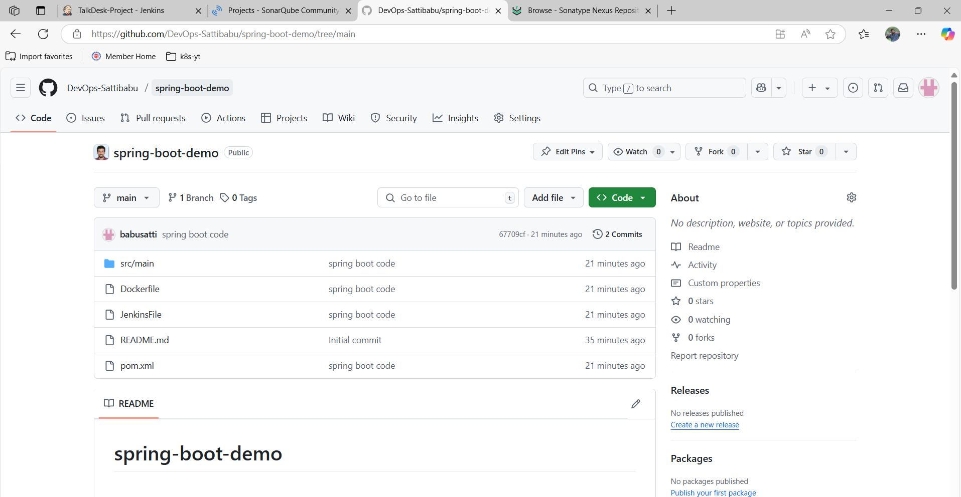
Jenkins Job: TalkDesk-Project_Demo
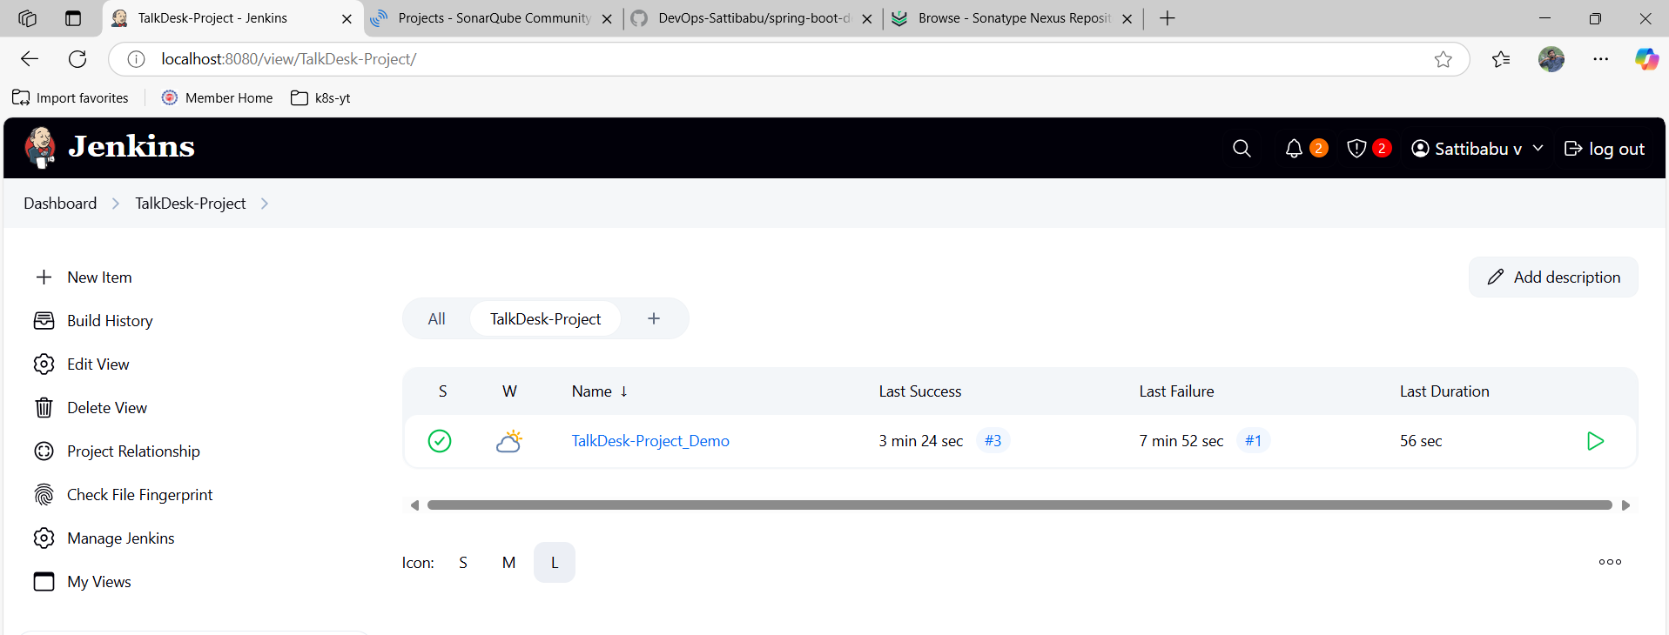
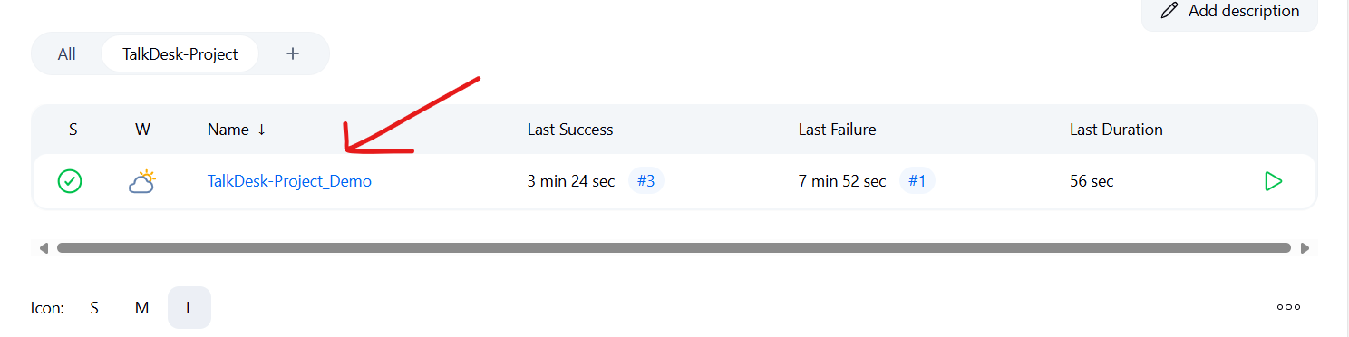
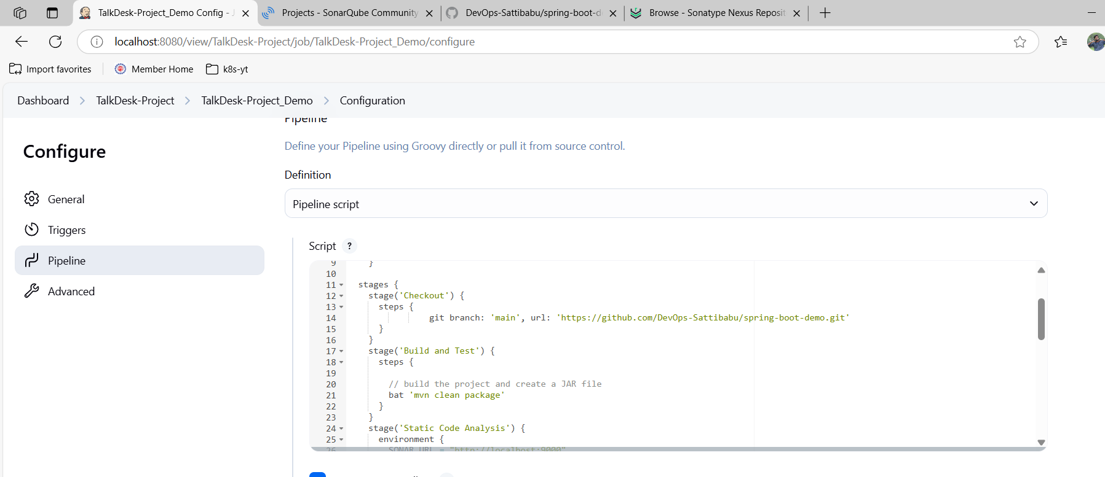
SonarQube:
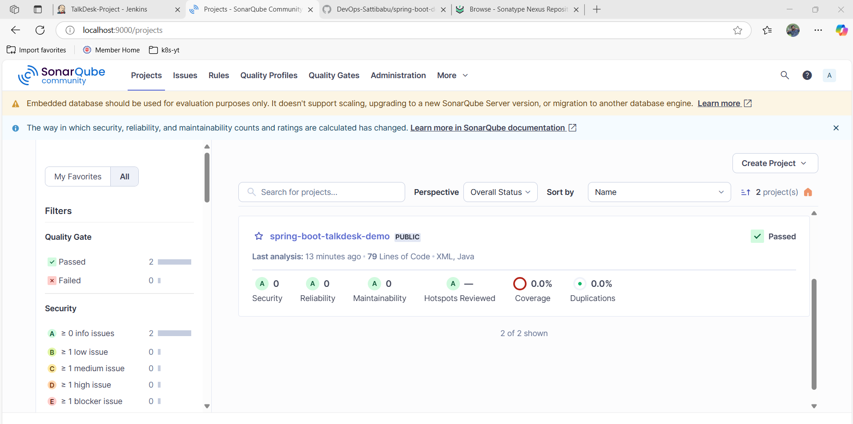
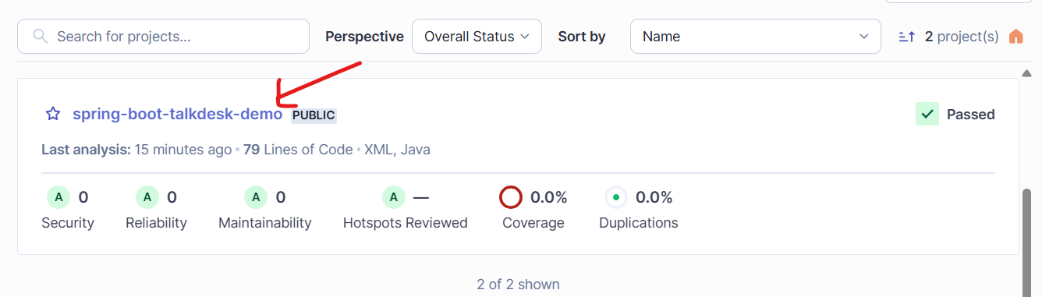

Nexus:
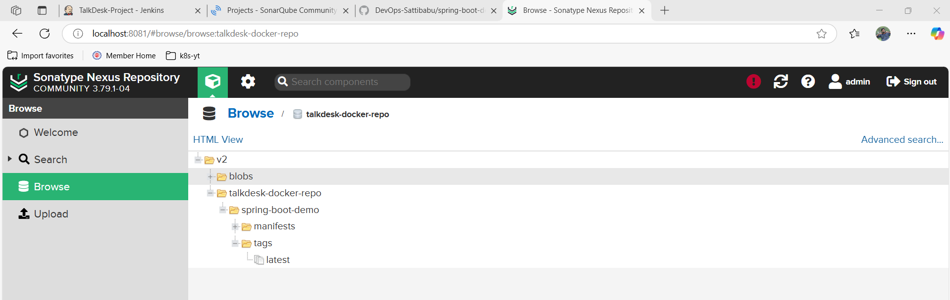
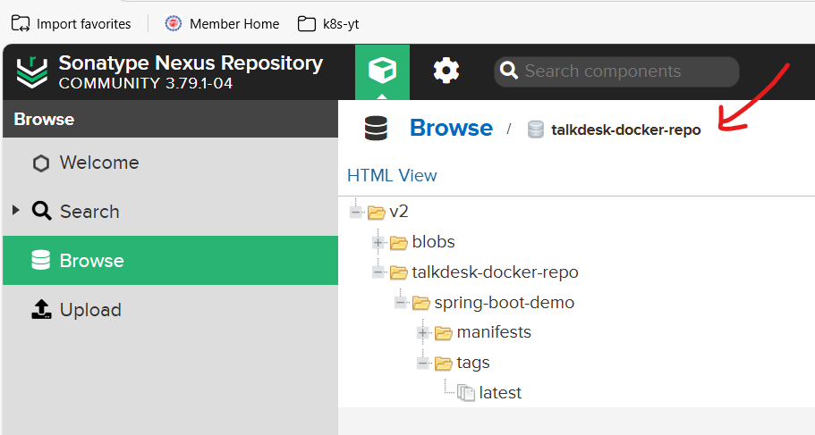

Docker:
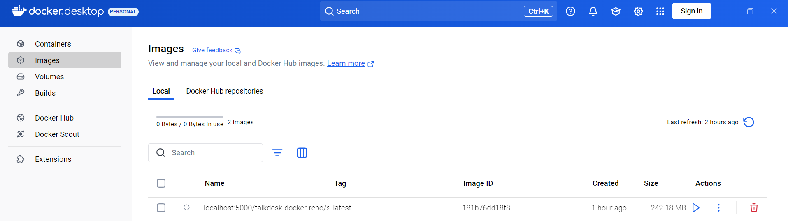

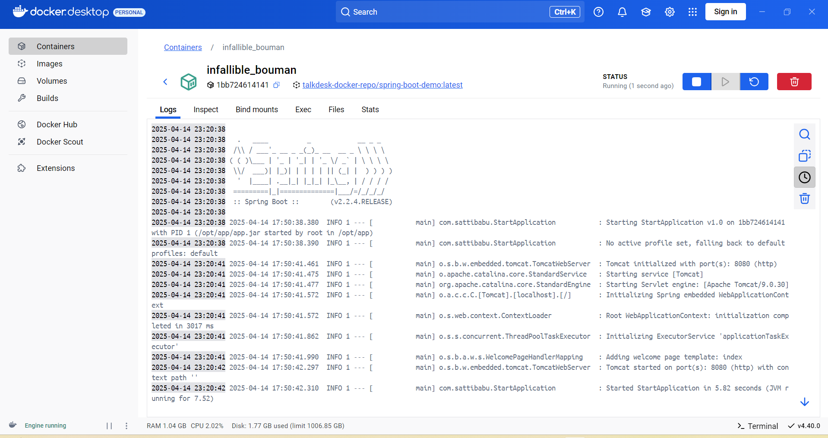
Run image:
